Pattison’s Academy for Comprehensive Education
(PACE) Charter School
BOARD OF DIRECTORS
February 19, 2019
BOARD MEMBERS PRESENT: Richard Gross, Laurie Sessa, Gerry Kelly, Maureen Cannon, Randy Disharoon, Paige Knowlson.
Attending on Conference Call: Penny Lewis, John Belissary.
Board Members Excused: Tom Reilly, Maurice Johnson, Jeff Crudup.
PA Staff Present: Paige Bogucki, Laura Del Duca, Julianna Greenhaw.
Guests: None
MEETING LOCATION: Conference Room, Charleston Medical Society, 198 Rutledge Place, Charleston.

Call to order: 5:03 pm
Call to Order and Welcome
Laurie Sessa chaired the meeting and called the meeting to order at 5:03 pm. She welcomed everyone in attendance and introduced Madison Anderson, our new Director of Development.

Approval of Minutes
The minutes of the January 15, 2019 PACE Board meeting minutes were reviewed. Gerry mentioned that his name should be added to the list of Excused Board Members for that evening. Maureen said she would make the change. With no other changes, Gerry made a motion for approval and Randy seconded the motion. With no further discussion, the minutes were unanimously approved.
Treasurer’s Report
Randy presented the PACE Statement of Revenues and Expenses, year to date through January 31, 2019. The Statement shows a total revenue of $682,149. Randy commented that the high income reflects the total funding for the Nurse position for the year as well as the total revenue from the Federal Government IDEA revenue for the year. These two funding sources are all that will be received in these categories for the rest of the fiscal year. Total expenditures for the same period amounted to $665,603 leaving a Total Net Income of $16,546. Randy noted that the budget includes a major payment of the Redemption of Principal which is the loan that is being paid off. The goal is to continue these payments and have the balance paid by the end of the fiscal year.
Randy also noted that both PACE and Pattison’s Academy have opened savings accounts which will serve as our reserve for the future. The Board was extremely pleased that the financials have moved to this very positive place. PACE is clearly on a solid financial ground.
New Business
Facilities – Paige stated that she and Julianna visited the St. Andrews Middle School (SAMS) facility and are reviewing the space requirements for school next year. Issues such as sink placement and cost analysis need to be resolved prior to the move to SAMS. They also met with Voyager regarding shared space and pupal integration. Paige and Julianna continue to target parent engagement and are optimistic that next school year will be a much richer environment than the current location.
Paige noted that the summer Camp of 2019 will be held on the grounds of the new school location. This information will be disseminated to all parents.
Transportation – Laurie began a discussion of the perennial problem of bus transportation and how the costs could be reduced. The biggest factor is the lack of adequate drivers for the buses. We have many applicants, but few people willing to accept the job. Even a dollar an hour increase does not seem to help the situation. Randy recommended reaching out to AARP or VA groups to recruit potential drivers/aides. Laura will try to contact these community groups that may have retirees looking for part-time work or even volunteering to assist with this problem.
Adjournment
With no further business to discuss, a motion for adjournment was made by Dick and seconded by Randy. The members unanimously concurred, and the meeting was adjourned.
Meeting Adjourned: 5:25pm
Next Meeting – Tuesday, March 19, 2019
Location – Office of Charleston Medical Society, 198 Rutledge Ave, Charleston
Time – 5:00pm
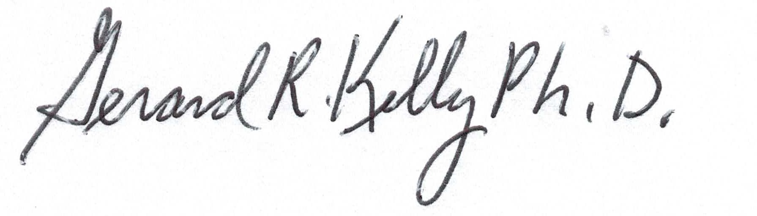_______________________________________________________________
Gerard Kelly, PhD
Secretary

